SIMATS ENGINEERING
ASSESSMENT TOOL 1 : Concept Mapping

COURSE NAME: | Cloud Computing and Big Data Analytics | COURSE CODE: | CSA1508

COURSE OUTCOME COVERED
CO1: Apply cloud computing technologies including hardware-software evolution, virtualization, web services, and service models to develop cloud-based solutions. (BL2)
Assessment Tool Weightage: 20%

Dave's Taxonomy: Imitation (Level 1)  Question Count: 4 | Total Marks: 50

Code of Conduct
I A Manvitha Devi (192372386) (Name / Reg No) certify that this submission is my original work and that I have adhered to the guidelines specified for this assessment.
I understand that any violation of academic integrity rules will result in disciplinary action.
Signature of the student: Manvitha

Assessment Tasks

Concept Mapping Tasks
Create concept maps for the following tasks. Each map must show key nodes, link labels, and a logical hierarchy.
- Concept Map 1: Cloud Computing Fundamentals. Include definition, characteristics, benefits, and limitations.

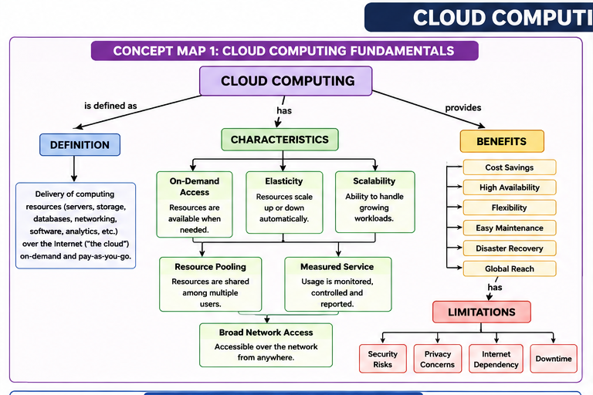
- Concept Map 2: Evolution of Cloud Computing. Connect hardware evolution, internet software evolution, distributed systems, and service delivery.
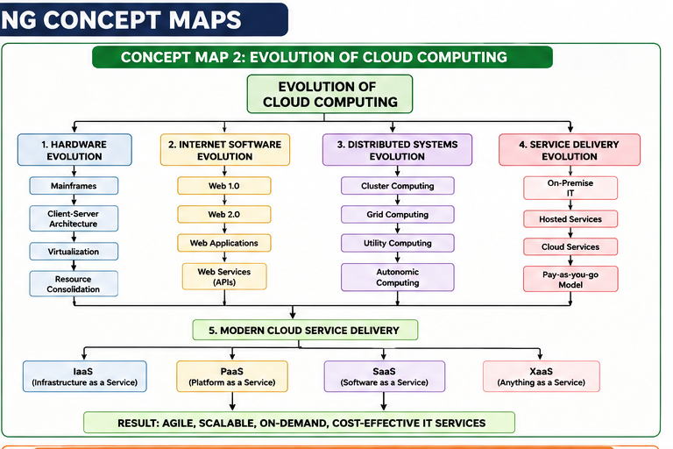

- Concept Map 3: Service Models. Map IaaS, PaaS, SaaS, and XaaS with provider responsibilities and user responsibilities.

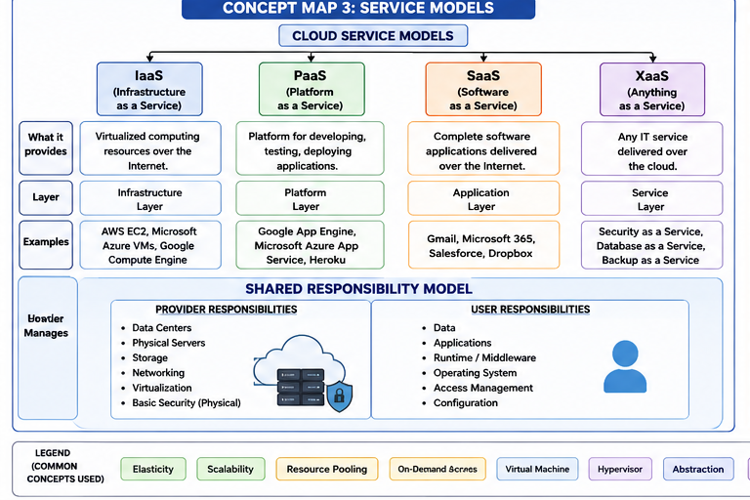

- Concept Map 4: Virtualization and Web Services as Enablers of Cloud. Show how these two concepts support cloud deployment and scalability.
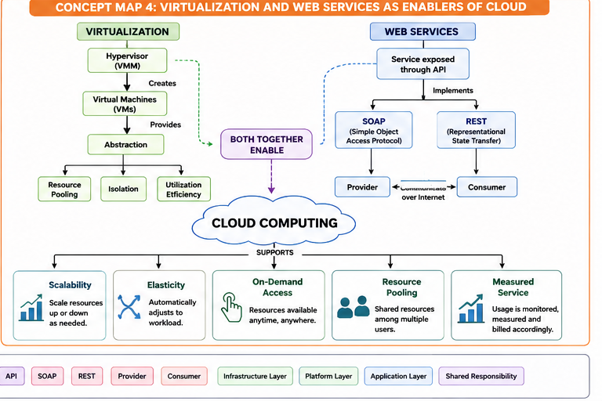
Expected concept nodes:
- Elasticity, scalability, resource pooling, on-demand access, measured service
- Virtual machine, hypervisor, abstraction, API, SOAP, REST, provider, consumer
- Infrastructure layer, platform layer, application layer, shared responsibility

Concept Mapping Rubric
Criteria | Weightage | Level 4 - Exemplary | Level 3 - Proficient | Level 2 - Developing | Level 1 - Beginning
Concept Identification | 25% | All major concepts are accurately identified | Most concepts are identified correctly | Limited concepts are identified | Essential concepts are missing
Relationship Mapping | 25% | Links between concepts are accurate and meaningful | Most links are correct | Some links are weak or unclear | Relationships are mostly incorrect
Hierarchy and Organization | 20% | Excellent structure with clear hierarchy | Mostly organized with minor issues | Basic structure with weak hierarchy | No logical organization
Technical Relevance | 20% | Map strongly reflects cloud course content | Mostly aligned to topic | Partially aligned to topic | Weak alignment to topic
Visual Clarity | 10% | Neat, readable, and easy to interpret | Generally readable | Somewhat cluttered | Poorly presented

Permitted Tools :
draw.io / diagrams.net, Lucidchart, MindMeister, Miro, Canva, PowerPoint, Google Drawings, or equivalent diagramming tool
Procedure for Preparing the Digital Concept Map
- Use the following procedure to prepare the diagram and upload evidence.
- Students who already know another diagramming tool may use it, but the exported evidence and source file must still be submitted.
- Open https://app.diagrams.net/ or the desktop version of draw.io / diagrams.net.
- Choose Device, Google Drive, or OneDrive as the save location according to availability.
- Create a blank diagram and name the file as CSA15_CO1_AT1_RegisterNumber_Concept_Map.drawio.
- Place the concept map title at the center or as a clearly visible anchor node.
- Add major cloud nodes: cloud definition, cloud evolution, cloud architecture, service models, deployment models, virtualization, web services, SOAP, REST, APIs, elasticity, scalability, resource pooling, measured service, and emerging paradigms.
- Connect nodes with labeled arrows such as uses, depends on, enables, scales through, communicates through, belongs to, supports, provides, consumes, or controls.
- Use colors meaningfully: one color for service models, one for cloud characteristics, one for API/web-service concepts, and one for concept map title-specific elements.
- Export the final diagram as PNG or PDF. Keep the editable .drawio source file also.
- Paste the exported diagram image or screenshot in this DOCX under Task 1.
- Upload the DOCX, exported PNG/PDF, and .drawio file to Google Classroom.

Task 1: Concept Map
Create a concept map in draw.io, Lucidchart, Miro, Figma, or any suitable diagramming tool. The map must connect cloud ecosystem, cloud actors, service models, deployment models, virtualization, web services, REST/SOAP APIs, scalability, elasticity, and the student's Project.
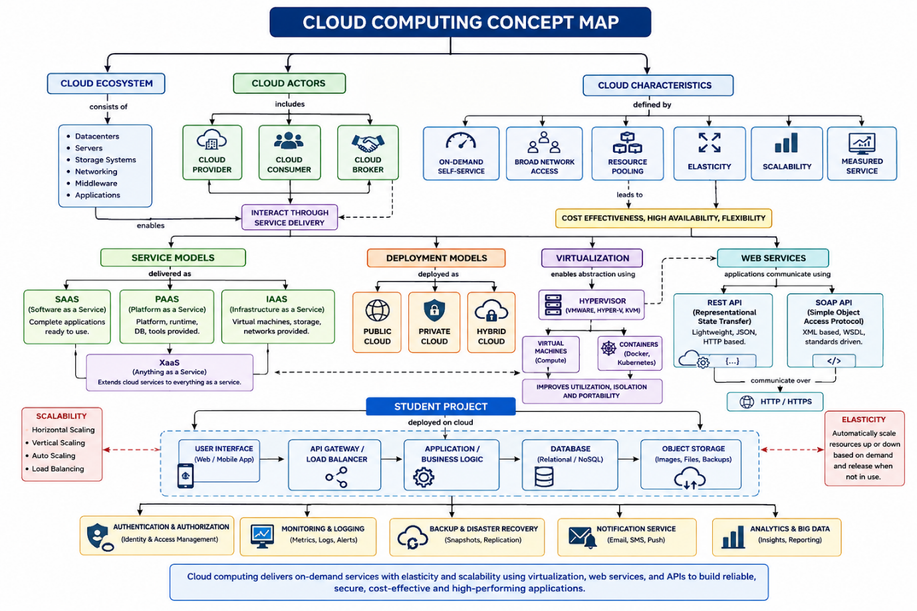

Task 2A: Service Model Responsibility Matrix
Prepare a technical matrix that compares SaaS, PaaS, IaaS, FaaS/serverless, database-as-a-service, storage-as-a-service, identity-as-a-service, and monitoring/logging services. For each selected service category, explain what is managed by the cloud provider, what is managed by the student application team, and why that split fits the Project.
Cloud Service Category | Managed by Cloud Provider | Managed by Student Application Team | Why the Split Fits the Project
SaaS (Software as a Service) | Hosts the application, performs updates, maintenance, security patches, and infrastructure management. | Manages users, application settings, and business data. | Enables the team to use ready-made software while focusing on project functionality.
PaaS (Platform as a Service) | Manages operating system, runtime environment, middleware, web server, networking, and auto-scaling. | Develops application code, REST APIs, business logic, and performs testing. | Simplifies application development without managing servers.
IaaS (Infrastructure as a Service) | Provides physical servers, storage devices, networking, virtualization, and data centers. | Configures virtual machines, operating systems, software installation, and security settings. | Offers full control when customized infrastructure is required.
FaaS / Serverless | Manages servers, runtime, scaling, availability, and execution environment. | Creates serverless functions, event triggers, and business logic. | Best suited for event-driven tasks such as processing requests or notifications.
Database-as-a-Service (DBaaS) | Maintains database servers, backups, replication, updates, availability, and security. | Designs database schema, creates tables, writes SQL queries, and manages application data. | Provides reliable and scalable data storage with minimal administration.
Storage-as-a-Service (STaaS) | Handles storage infrastructure, replication, encryption, backup, and high availability. | Uploads, retrieves, organizes, and manages application files and documents. | Ideal for storing images, reports, backups, and project files.
Identity-as-a-Service (IDaaS) | Provides authentication, Single Sign-On (SSO), Multi-Factor Authentication (MFA), and identity management. | Defines user roles, permissions, and authorization policies. | Ensures secure user authentication and controlled access.
Monitoring & Logging Service | Collects system logs, infrastructure metrics, dashboards, alerts, and performance monitoring. | Configures application logs, analyzes errors, and monitors application performance. | Helps maintain application reliability and quickly detect issues.

Task 2B: Cloud Service Decision Matrix
Map Project modules to cloud services. Include authentication, frontend hosting, backend/API layer, database, object storage, analytics/logging, notification, AI/Python module, security, CI/CD, backup, and monitoring. Students should justify the most relevant service choices instead of forcing every possible cloud service into the design.
Project Module | Recommended Cloud Service | Justification
Authentication | Identity-as-a-Service (IDaaS) | Provides secure user login, authentication, role-based access control (RBAC), and Multi-Factor Authentication (MFA).
Frontend Hosting | Static Web Hosting / App Service | Hosts the web application with high availability, fast content delivery, and automatic scaling.
Backend / API Layer | Platform-as-a-Service (PaaS) | Runs REST APIs and application logic without managing the underlying infrastructure.
Database | Database-as-a-Service (DBaaS) | Stores application data securely with automated backup, replication, and high availability.
Object Storage | Storage-as-a-Service | Stores images, documents, videos, backups, and other unstructured project files reliably.
Analytics / Logging | Cloud Monitoring & Logging Service | Collects application logs, performance metrics, and usage analytics for troubleshooting and optimization.
Notification Service | Cloud Notification Service | Sends email, SMS, or push notifications to users for alerts and updates.
AI / Python Module | Serverless Functions (FaaS) or Cloud Virtual Machine | Executes Python scripts and AI/ML models efficiently with automatic scaling based on workload.
Security | IAM, Firewall, Encryption Services | Protects data and applications using identity management, firewalls, SSL/TLS encryption, and access policies.
CI/CD | Cloud DevOps / CI-CD Pipeline | Automates code building, testing, and deployment, reducing manual effort and deployment errors.
Backup | Cloud Backup Service | Automatically backs up databases and files, enabling quick disaster recovery and data restoration.
Monitoring | Cloud Monitoring Service | Continuously monitors CPU, memory, storage, API response time, and system health while generating alerts for failures.

Task 3: API Flow, Elasticity, and Scalability Design
Draw a professional cloud-flow diagram for the Project modules. The diagram must show user app or web app, API gateway/backend service, authentication, compute layer, database, object storage, analytics/logging, monitoring, security boundaries, and scaling points. Students may replicate the given visual pattern, but all components and labels must be customized to their own architecture.
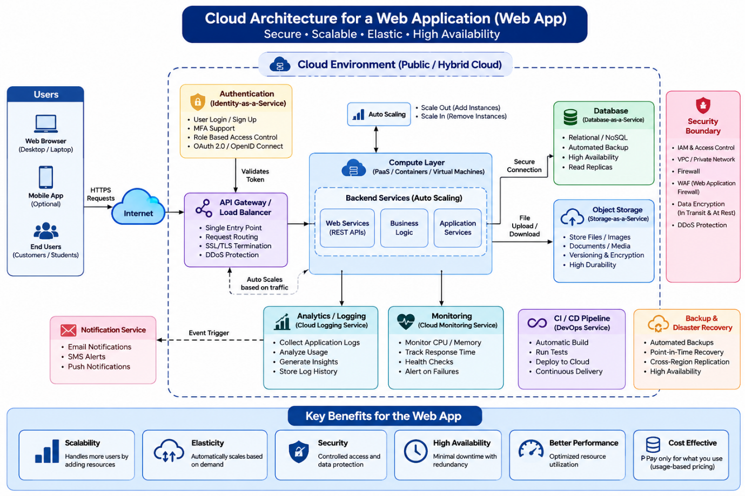

Task 4: Technical Justification
Write a concise justification explaining how the diagram and matrices prove CO1. The justification must discuss service model selection, API role, elasticity, scalability, virtualization or managed compute choice, and cloud responsibility boundaries.
ANSWER:
The concept map and matrices demonstrate CO1 by clearly explaining cloud computing principles and their relationships. The selected service models (IaaS, PaaS, and SaaS) show how different user requirements are addressed. APIs and web services enable communication and integration between cloud applications, improving interoperability. Scalability and elasticity allow resources to expand or shrink based on demand, ensuring high performance and cost efficiency. Virtualization supports efficient resource sharing, while managed compute services reduce infrastructure management tasks. The concept map also illustrates shared responsibility boundaries, where cloud providers manage infrastructure and customers manage applications and data, ensuring secure and efficient cloud operations.

- Evaluate the effectiveness of your concept map in representing cloud computing principles. Which design decisions most strongly support your solution, and why?
ANSWER:
The concept map effectively represents cloud computing by organizing concepts into a clear hierarchy. It connects cloud characteristics, service models, deployment models, and technologies, making their relationships easy to understand. The use of linking phrases improves clarity, while grouping related concepts supports better visualization. These design decisions help explain how cloud computing components work together to deliver reliable and efficient services.

- Analyze how scalability, elasticity, and resource management influence the architecture shown in your concept map. What challenges could arise if these capabilities were absent?
ANSWER:
Scalability enables the system to increase resources as workloads grow, while elasticity automatically adjusts resources based on demand. Resource management ensures efficient allocation and utilization of computing resources. Without these capabilities, applications may experience slow performance, resource shortages, higher operational costs, and poor user experience during peak workloads. Overall system efficiency and availability would also decrease.

- Justify the selection of the APIs, web services, or cloud services included in your concept map. How do they contribute to the overall functionality and efficiency of the system?
ANSWER:
APIs and web services are included because they allow secure communication between cloud applications and external systems. They support data exchange, automation, and integration across different platforms. Cloud services such as IaaS, PaaS, and SaaS provide flexible infrastructure, development environments, and ready-to-use applications. Together, these technologies improve system efficiency, reduce development time, and support scalable cloud-based solutions.

- Critically examine the relationships between the components in your concept map. How do these interactions improve reliability, performance, or user experience?
ANSWER:
Developing the concept map improved my understanding of how cloud computing components are interconnected. It clarified the relationships between service models, deployment models, virtualization, APIs, and resource management. If redesigned, I would include more real-world examples, security mechanisms, and modern cloud-native technologies such as containers and serverless computing to make the concept map more comprehensive and practical.
- Reflect on the process of developing your concept map. How has creating and analyzing the map changed your understanding of cloud computing architecture, and what improvements would you make if you were redesigning it?
ANSWER:
Developing the concept map improved my understanding of how cloud computing components are interconnected. It clarified the relationships between service models, deployment models, virtualization, APIs, and resource management. If redesigned, I would include more real-world examples, security mechanisms, and modern cloud-native technologies such as containers and serverless computing to make the concept map more comprehensive and practical.

Expected Digital Evidence
- Editable diagram source file and exported PNG/PDF for the concept map.
- Completed service model responsibility matrix and cloud service decision matrix.
- Architecture/API flow diagram exported as PNG/PDF.
- README file containing title, tools used, repository structure, and a short CO1 reflection.
GitHub and Google Classroom Submission
- Create a repository using a clear name: CSA15_CO1_AT<Number>_<RegisterNumber>.
- Upload editable source files, exported PDF/PNG evidence, screenshots, and a short README explaining the work.
- Keep filenames professional and include the register number where appropriate.
- Submit only the GitHub repository link in Google Classroom before the deadline.
- Ensure the repository is accessible to the faculty evaluator during assessment.
Implementation Note
Faculty may evaluate the submitted evidence digitally using repository inspection, diagram quality, oral explanation, and CO-aligned rubric scoring. The focus is on technical understanding, cloud design reasoning, and hands-on evidence rather than routine written work.

